Overview
The purpose of the Request official letter function is to provide the ability to quickly and easily access your letters and statements through MyAccount. Letters available include:
- pension statements
- concession statements
- income and asset statements
- card confirmation letters.

Your letters and statements can be accessed online and you can choose to have them:
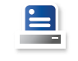
Downloaded and printed

Mailed to you by post

Picked up from your local VAN office

Requesting a letter screen.
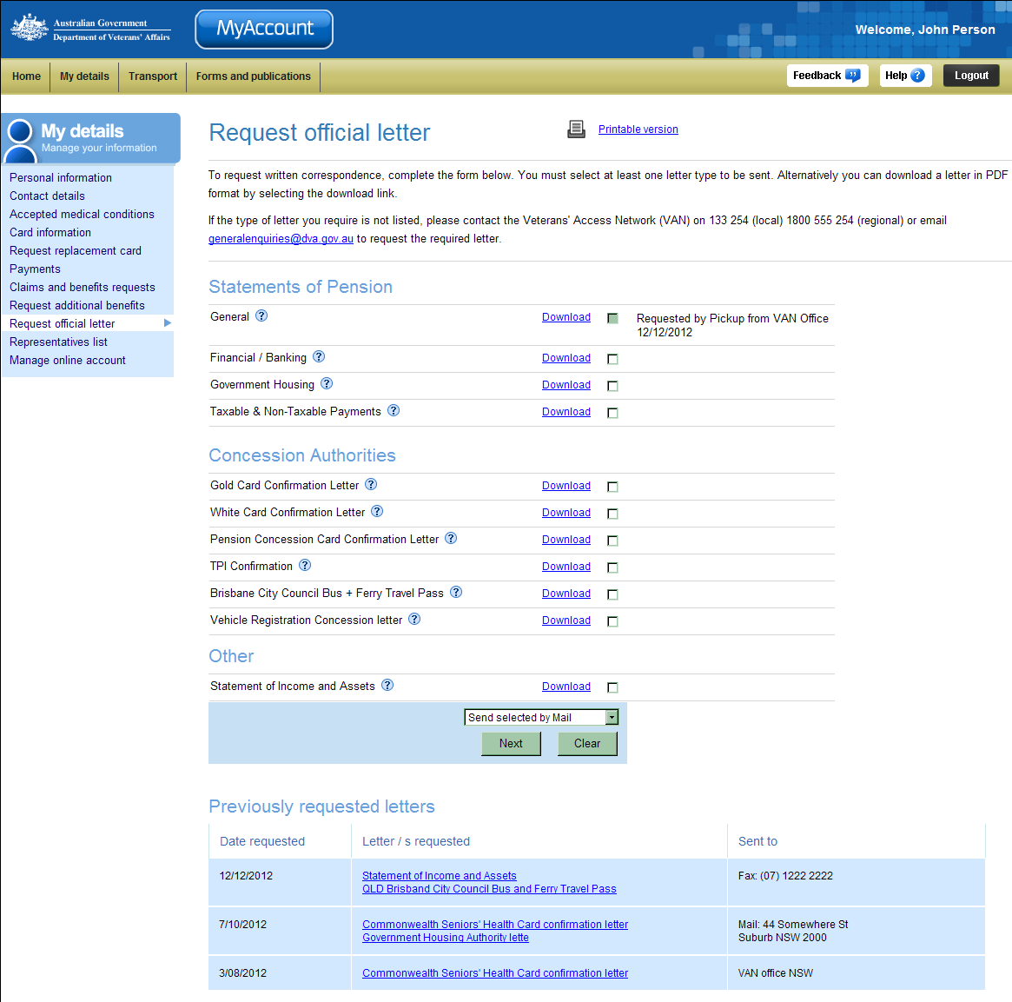
Letters available will be displayed.
Note: Only letters relevant to you and your circumstances will display.
Letters requested previously.
To request official letters via MyAccount you must be logged into MyAccount.
When request official letters, fields marked with a red asterisk (*) are mandatory.

Requesting a letter
To request an official letter:
- From the list of letters displayed, tick the check box next to the desired letter(s).
 | Additional details regarding the letter can be accessed by moving your mouse over the icon.
- From the drop down list select how you would like the letter(s) to be delivered e.g. send selected by mail or pick up from VAN office.
- Click on the Next button.
The following table describes the two options available when requesting a letter.
Request Option | Details
Send selected by Mail | The Confirm delivery address screen displays.  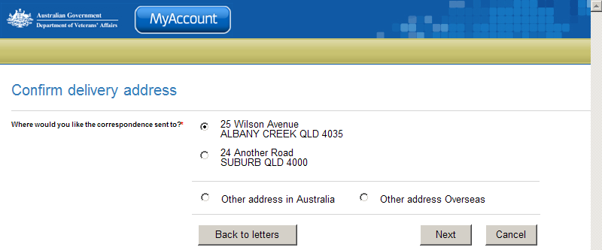  - Select where you would like the letter to be sent to.  - Click on the Next button.  The Confirm delivery details screen displays.  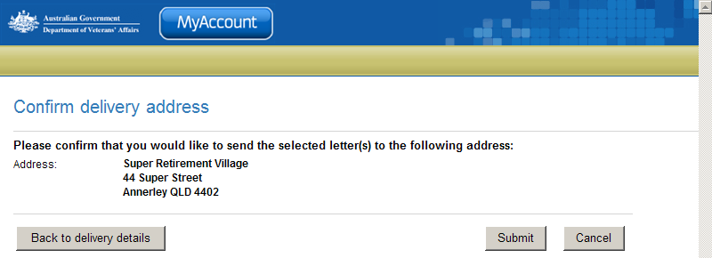  - Confirm the delivery details for the letter(s).  - Click on the Submit button to finalise the request.
  Address details stored in MyAccount will display here.
  If you wish to change you contact details, please go to the Contact details page and update your details.
  If Other address in Australia or Other address Overseas are selected, address fields will display for you to populate.
Pick up from VAN office | The Delivery details screen displays.  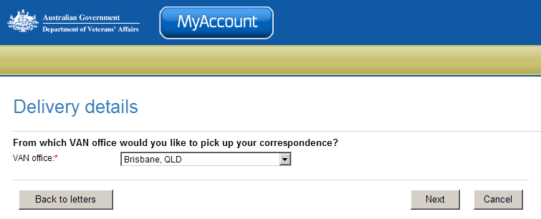  - From the VAN office drop down list, select your local VAN office.  - Click on the Next button to finalise the request.

The Request official letter screen displays.
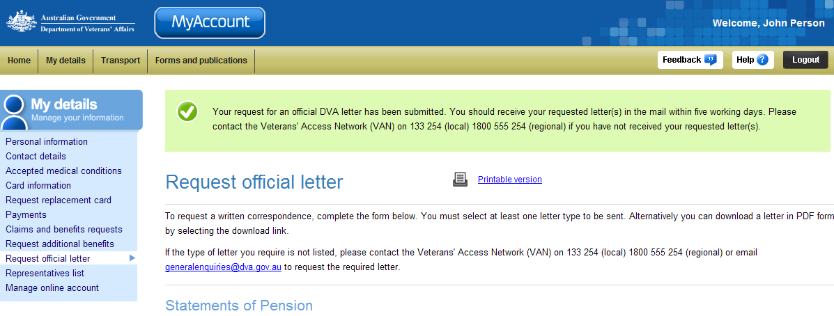
Your request for an official DVA letter has been successfully submitted.
Please note, if you requested your letter(s) to be sent via mail, you should receive your letters within five working days. If you have requested to pick up your letter(s) from a VAN office, call 1800 555 254 to arrange a time to pick up your letter(s).

Download a letter
To view downloaded letters you need a copy of Adobe Reader (or Adobe Acrobat). This may already be installed on your computer.
If required, you can get a free copy of Adobe Reader at: http://get.adobe.com/reader/

To download and print a letter
- Click on the Download link to download letter in PDF format.

The File Download dialog box displays.
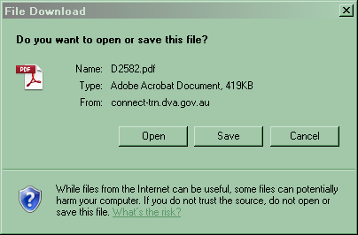
- Click on the Open button.

The letter displays in Adobe Acrobat or in your web browser.
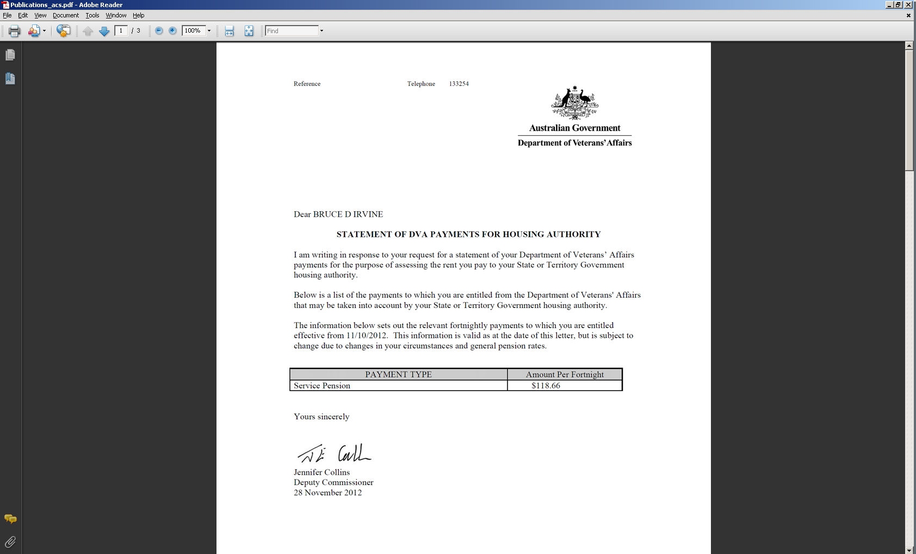
- To print the letter, click on the icon on the toolbar or click on the File menu > Print...
- To save a copy of the letter, click on the File menu > Save As… > PDF… and choose a location and file name for the letter.

Other functions
 | To view another section and information from My details, click on a link in the My details menu to the left of the page.
 | To get additional help with the Publications screen, click on the Help button at to the top right of the page.
 | When you are finished using MyAccount, to log out and finish using the service in a secure way, click on the Logout button.

